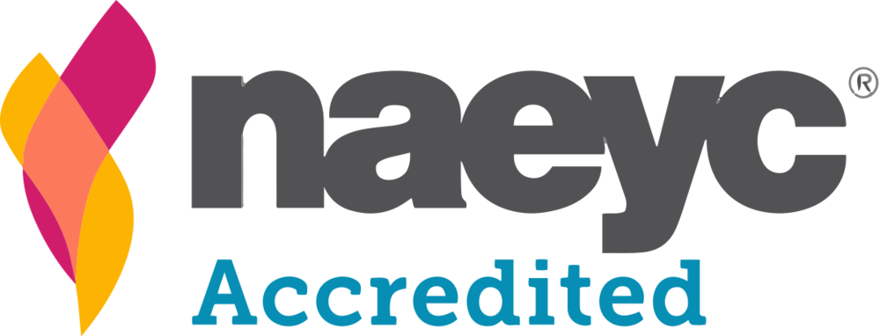
NAEYC GUIDELINES

NAEYC has set 10 standards for early childhood programs that can help families make the right choice when they are looking for a child care center, preschool, or kindergarten. The standards and criteria are also the foundation of the NAEYC Accreditation system for early childhood programs. To earn accreditation, programs must meet all 10 standards.

1 Relationships - The program promotes positive relationships among all children and adults. It encourages each child’s sense of individual worth and belonging as part of a community and fosters each child’s ability to contribute as a responsible community member.

2 Curriculum - The program implements a curriculum that is consistent with its goals for children and promotes learning and development in each of the following areas: social, emotional, physical, language, and cognitive.

3 Teaching - The program uses developmentally, culturally, and linguistically appropriate and effective teaching approaches that enhance each child’s learning and development in the context of the curriculum goals.

4 Assessment of Child Progress - The program is informed by ongoing systematic, formal, and informal assessment approaches to provide information on children’s learning and development. These assessments occur within the context of reciprocal communications with families and with sensitivity to the cultural contexts in which children develop. Assessment results benefit children by informing sound decisions, teaching, and program improvement.

5 Health - The program promotes the nutrition and health of children and protects children and staff from illness and injury. Children must be healthy and safe in order to learn and grow.

6 Teaching Staff - The program employs and supports a teaching staff with the educational qualifications, knowledge, and professional commitment necessary to promote children’s learning and development and to support families’ diverse needs and interests.

7 Families - The program establishes and maintains collaborative relationships with each child’s family to foster children’s development in all settings. These relationships are sensitive to family composition, language, and culture. To support children’s optimal learning and development, programs need to establish relationships with families based on mutual trust and respect, involve families in their children’s educational growth, and encourage families to fully participate in the program.

8 Community Relationships - The program establishes relationships with and uses the resources of the children’s communities to support the achievement of program goals.

9 Physical Environment - The program has a safe and healthful environment that provides appropriate and well-maintained indoor and outdoor physical environments. The environment includes facilities, equipment, and materials to facilitate child and staff learning and development.

10 Leadership and Management - The program effectively implements policies, procedures, and systems that support stable staff and strong personnel, and fiscal, and program management so all children, families, and staff have high-quality experiences.

